# Design stage

For lab project 4 I have chosen to create a school information management system that will keep records on students, class, courses, and teachers. This program will implement the use of classes and a graphical user interface to allow the end user to store view and modify the data stored within. To store this data between launches, a plan has been used to make use of a feature called serialisation were created objects can be saved to a file as a string upon ending the program and then loaded back into objects again when the project next starts

## UML

Below is shown a UML diagram of the classes that will be created for the project.

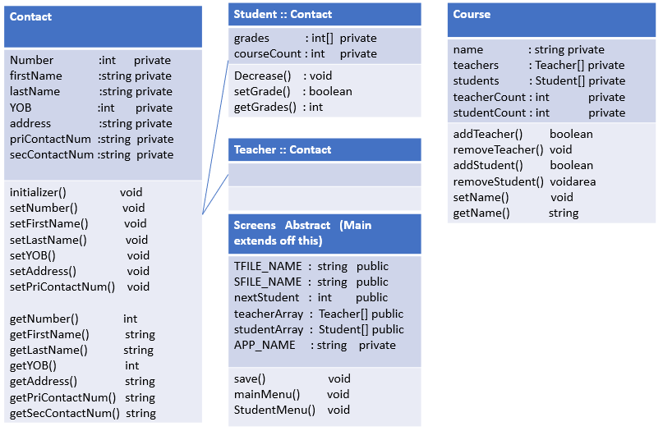

## User Interface

Below will be shown a rough mock-up of planned graphical interface screens (To stop this document form getting too large only the main menu, students object viewer, and add student screens will be shown. This can be done as in principle these screens are planned to be very much the same as these).

### Main menu

------------------------------------------------------------------------------------------------------------------------------------------------------------------------------------------------------------------------------------

Main Menu

Courses

Students

Teachers

------------------------------------------------------------------------------------------------------------------------------------------------------------------------------------------------------------------------------------

### Student records

------------------------------------------------------------------------------------------------------------------------------------------------------------------------------------------------------------------------------------

Student records

add

This would be a field for a single Student object, this will be duplicated many times if there are many Student objects.

Student information

delete

change

------------------------------------------------------------------------------------------------------------------------------------------------------------------------------------------------------------------------------------

### Change Student records

------------------------------------------------------------------------------------------------------------------------------------------------------------------------------------------------------------------------------------

Student record change

This would be reached by clicking on an object’s change button.

change

Student information input fields

------------------------------------------------------------------------------------------------------------------------------------------------------------------------------------------------------------------------------------